Practical - 10

**AIM :**   **Orchestration of ML project containers using Kubernetes.**

The objective of this lab is to introduce you to the fundamentals of orchestrating applications with Kubernetes. You will learn how to define, deploy, and manage containerized applications using Kubernetes manifests.

**Step 1:** Verify Kubernetes Cluster

Ensure your Kubernetes cluster is up and running by checking the cluster nodes:

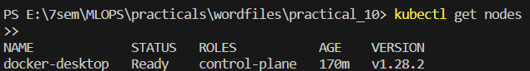

**Step 2:** Define a Deployment using YAML manifest and apply the deployment to your cluster:

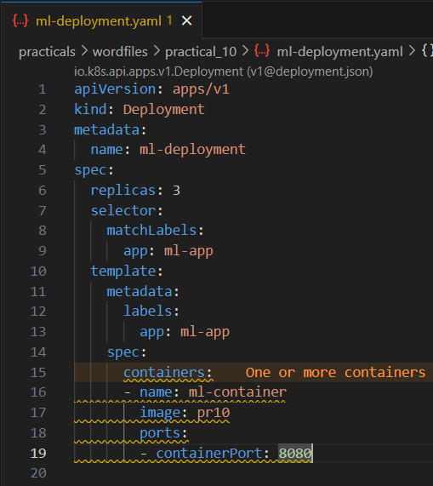

Apply the deployment:



**Step 3:** Describe Deployment

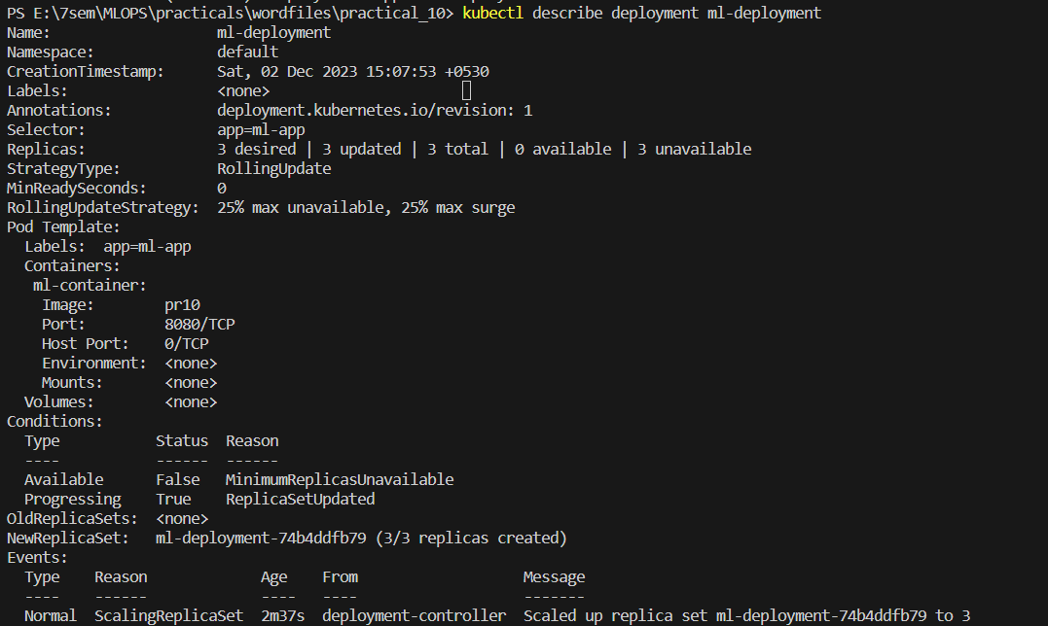

**Step 4:** Expose Service



**Step 5:** Access the Service



**Step 6:** Scale Deployment



**Step 7:** Update Deployment

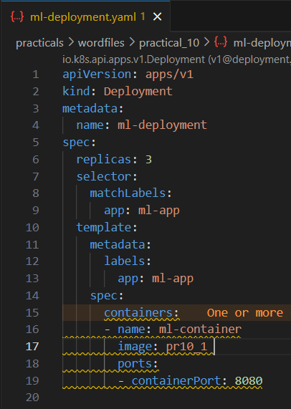



**Step 8:** Rollout Status



**Step 9:** Rollback Deployment



**Step 10:** Delete Resources



